

Disaster/Emergency Management Plan

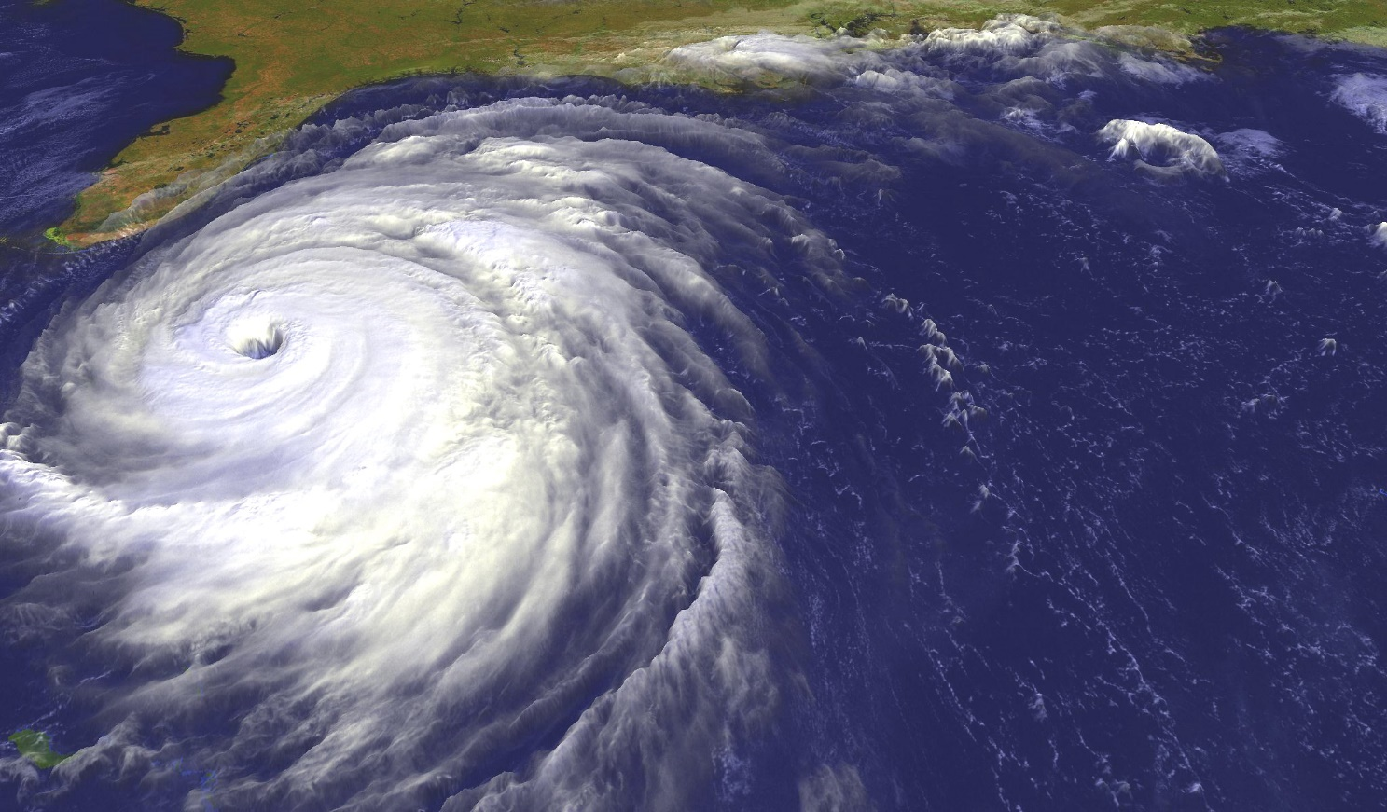

DISASTER/EMERGENCY MANAGEMENT PLAN
FOR THE
ST. AUGUSTINE LIGHTHOUSE AND MARITIME MUSEUM
August, 2016

Revised 10/30/03, R. Cain
2nd Revision 6/26/05, R. Cain
3rd Revision 5/30/15, Facilities and Risk Management Board Committee
4th Revision 8/23/2016, R. Cain, K. Fleming
Board Vote: 9/1/2016
5th Revision 9/16/2019, R. Cain
6th Revision 3/24/2020, R. Cain
7th Revision 8/17/2021, R. Cain

TABLE OF CONTENTS

- Safety Committee ……………………………………………………………….3
  - Introduction .………………………………………………………………...3
  - The Property ………………………………………………………………….4
  - Access ………………………….………………………………………………..4
  - Emergency Egress ……………………………..…………………………..8
  - Emergency Services ……..………………………………………………..9
  - Communications …………………………………………………………….9
  - Training ………………………………………………………………………….9
  - Levels of Emergency ………………………………………………………10
  - Initiating the Disaster Plan …………………………………………….11
  - Site Map and Photos ……………………………………………………..13
  - Emergency Code Detail ………………………………………………….16

- Natural Disasters ……..………………………………………………………….18
  - Fire Guidelines ……………………………………………………………….19
  - Power Outage/Lightning Strike ………………………………………21
  - Flooding …………………………………………………………………………22
  - Hurricane ……………………………………………………………………….22
  - Hurricane Evacuation …………………………………………………….23

- Disaster Recovery…………………………………………………………………29
- Important Phone Numbers ………………………………………………….30
- Checklists …………………………………………………………………………….31
- Appendices
Appendix A – Floor Plans and Emergency Exits ……………………35
Appendix B – Emergency Phone Tree ………………………………….40
Appendix C – Lightning Policy/Guidelines ……………………………44

Section 1 - Introduction

What is a Disaster?

A disaster is any unexpected, life, property or collection-threatening event. With the beginning of the 21st Century, and during its first decade and a half, threats increasingly come, not only from natural or elemental causes, but also from human causes. Significant threats to life come from active shooter situations, civil disturbances, bomb threats, and theft, as well as medical emergencies. These situations must be considered along with traditional threats from fire, flood, and hurricane. The most common disaster is fire. 75% of fires in cultural institutions are caused by arson.

The Museum plans for all contingencies. A safety committee has been established to review our plans annually and update them.

Safety Committee:
Chairman & Primary Safety Officer - Rick Cain, Director of Museum Services
Co-Chair & Assistant Safety Officer – Jason Smith, Facilities Supervisor
Kathy A. Fleming, Executive Director
Airielle Cathers, Dive Safety Officer
Starr Cox, Archaeological Conservator
David Popp, Maintenance
Barb Holland, Collections Manager
Susan Mills, Comptroller

The St. Augustine historic lighthouse tower is one of the most visible symbols of the Nation’s Oldest continuously occupied European Port City in the continental United States. Therefore, consideration must be given to the possibility of it being a high priority target for a terrorist action, hostage situation, or place of civic protest. While the city of St. Augustine hopefully will remain low priority as a potential target, plans must be made in the case of any emergency. This disaster plan will address those concerns while also addressing the concerns most likely to occur, hurricane, tropical storms and potential flooding, as well as that which has already occurred on the property, fire. The human element will be addressed first, followed by physical disasters after a short orientation to the physical property as well as primary transportation and law enforcement assets and corridors.

The Property

The St. Augustine Lighthouse & Maritime Museum (The Museum, or the Lighthouse) property is located on the north end of Anastasia Island, a 17-mile-long barrier island separated from the mainland by the Intracoastal Waterway (ICW), approximately 1.4 miles southeast of historic downtown St. Augustine.
Structures on the site include a 4,500 sf. Visitors Center built in 2000; a 165 ft. operational lighthouse tower constructed between 1871 and 1874, a two-story Keepers’ House 1876; Museum, a World War II era 1941 U.S. Coast Guard Barracks, and a 1936 Garage used as a Jeep maintenance facility during WWII. The buildings sit on a six-acre parcel of maritime hammock, which is heavily wooded with live and water oaks, magnolia and other native species. The land to the northern side of the site is younger has been clear cut in the 1930’s to allow the breeze. Some of the tree cover is aging and annual trimming and tree removal when rot is noticed is carried out, as are periodic replanting of live oak and cedar trees.

Coastal highway A1A is located approximately 0.3 miles west of the tower with primary vehicle access via Red Cox Road turning east off of Scenic Highway A1A (Anastasia Blvd.) just south of the property. A city park and county boat ramp with access to Salt Run and Matanzas Bay are located to the east of the property.

R.B. Hunt Elementary School and Anastasia State Park are located to the south and southeast of the site respectively with a small residential neighborhood located between them. Residential neighborhoods also exist to the north and west of the site with primary north approach access via White St. to Lighthouse Ave. off of Scenic Hwy A1A.

Access

There are three primary corridors for vehicular access to the Island. Scenic Hwy A1A coming from the north and south ends of the island, the Hwy 312 Bridge coming from U.S. Hwy 1, and the Hwy 206 Bridge coming from U.S. Hwy 1.
Scenic Hwy A1A (Anastasia Blvd.) crosses onto the north end of the island from downtown St. Augustine via the historic Bridge of Lions, a two-lane drawbridge constructed approximately ninety years ago. From the west side of the bridge, A1A continues north before crossing the ICW over to Vilano Beach via the Usina Bridge on the north side of the Matanzas Bay. Proceeding west from the Bridge of Lions on King St., it is only 0.8 miles to U.S. Hwy 1 (Ponce de Leon Blvd.). U.S. 1 then connects with Hwy 16 (Usina Highway) to the north which runs west to I-95.

Highway 312 runs east/west, crossing Hwy A1A only 1.6 miles south of the lighthouse. This large, four-lane highway crosses the ICW via a large stationary, span bridge prior to intersecting U.S. Hwy 1 on the west side of the bridge. It then connects with I-95 via Hwy 207.
Highway 206 runs east/west, intersecting Hwy A1A approximately 7.8 miles south of the lighthouse at Crescent Beach. Hwy 206 crosses the ICW via a two-lane, drawbridge and intersects U.S. Hwy 1 to the west.

Approximately 17 miles to the south of the lighthouse, Hwy A1A leaves the island crossing the Matanzas Inlet via a two-lane, stationary span bridge. Hwy A1A is a four-lane thoroughfare from the north end of the island and south through St. Augustine Beach. The highway then narrows to two-lane just north of Butler Beach.

Water access is via Salt Run, a narrow channel of tidal inlet separating the head of the island from Conch Island to the east in Anastasia State Park. Conch Island separates Anastasia Island from the open Atlantic Ocean. A small city boat ramp sits across Red Cox Dr. from the lighthouse.

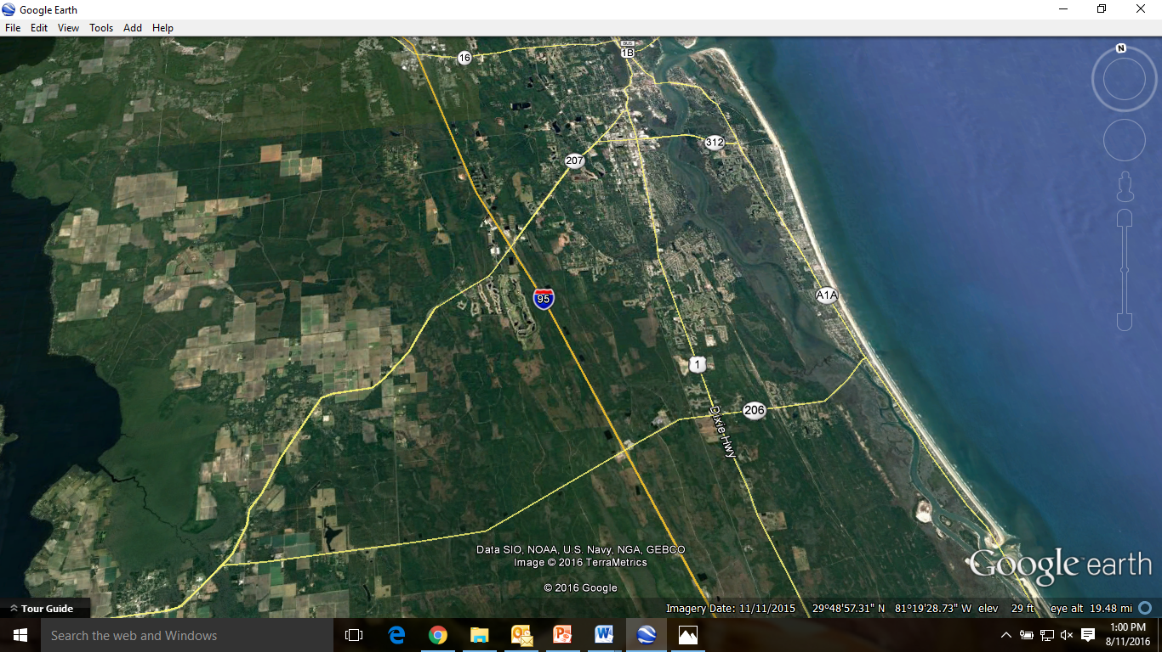
Aerial map showning St. Johns River on the left and the Atlantic Ocean on the right. Anastasia Island is visible in it’s entirety just west of the ocean with 3 major access routs to I-95. Succesive maps will be progressively magnified over the lighthouse property.
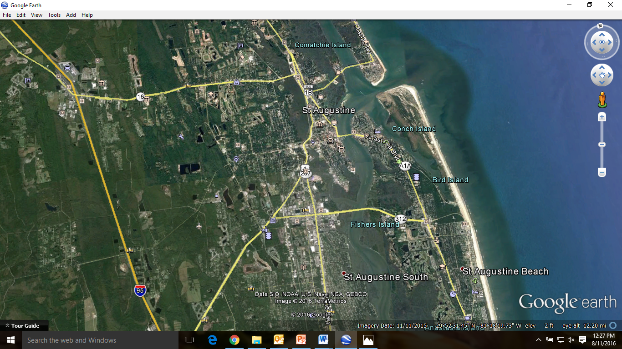

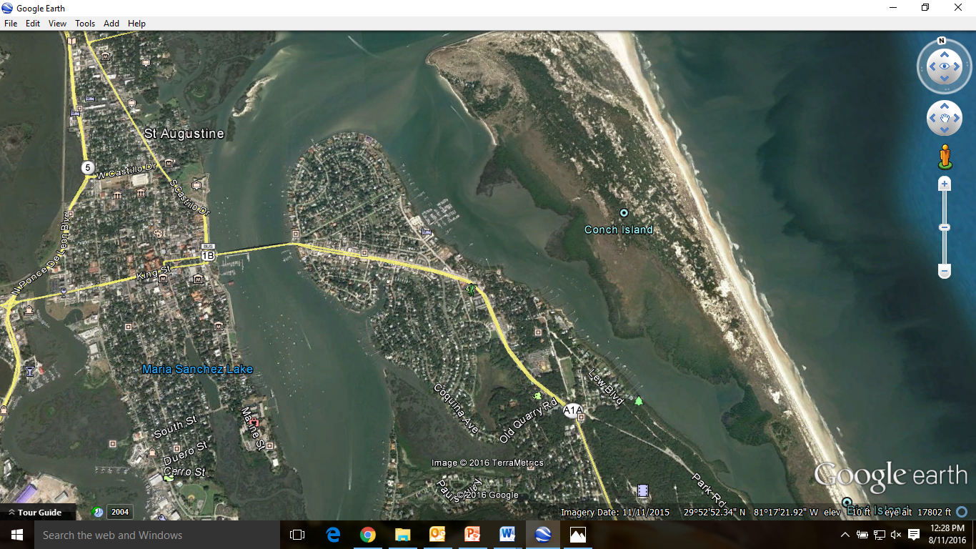
Here the head of Anastasia Island is clearly defined between the city of St. Augustine to the left and Conch Island on the right. The Bridge of Lions is seen center left crossing the ICW onto the island. The soccer field is clearly visible just above the “A1A” label on the island, with Anastasia State park comprising the wooded area below it as well as Conch Island.
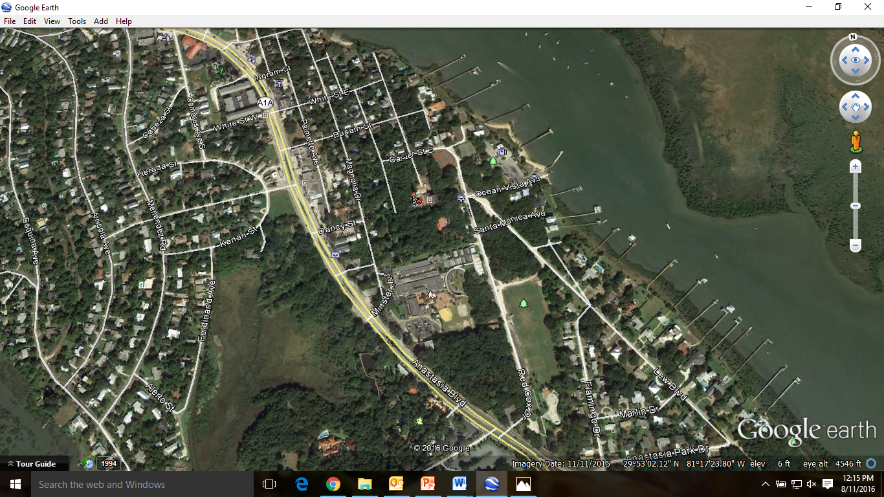
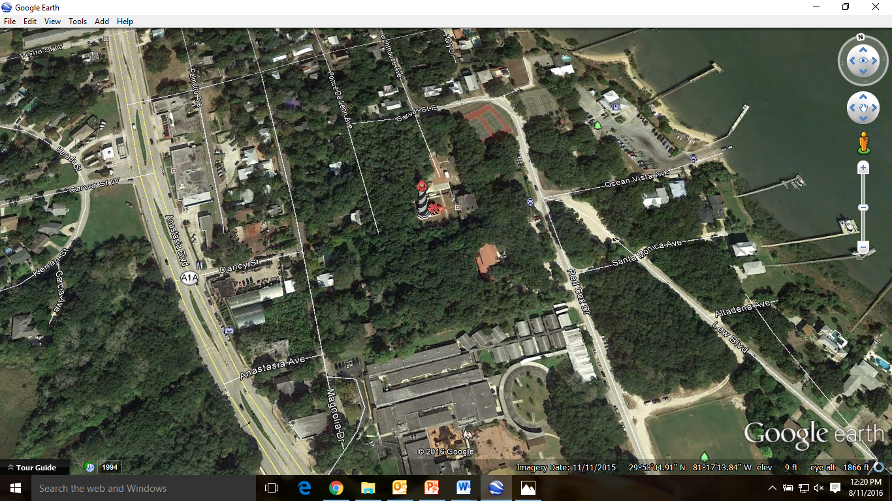
Note the lighthouse tower in the center of the photo surrounded by six acres of wooded maritime hammock. The red roof in the trees just below the tower is the Visitor’s Center. A tennis court is located on the NE corner of the property. R.B. Hunt Elementary School and soccer field are at the bottom of the photo. The boat ramp is to the right and Scenic Hwy A1A is to the left.

__________________________________________________________________________________________

Emergency Egress

Considering the limited amounts of vehicular traffic handled by the drawbridges, and the amount of congestion encountered in historic, downtown St. Augustine, the primary route of emergency egress is via Scenic Hwy A1A south to the Hwy 312 Bridge west. This four-lane, stationary span can handle large amounts of vehicular traffic and directly connects with U.S. Hwy 1 and U.S. Hwy 207, both of which provide four-lane corridor connections with I-95.
Consideration for water evacuation is limited by the water depth in Salt Run. Water depth at the boat ramp varies between nine feet at high tide to five feet at low tide making it accessible only for small water patrol law enforcement vessels, pontoon boats, or other pleasure craft, as well as the standard 25-foot Defender Class U.S. Coast Guard (USCG) patrol boat. St. Johns County operates a water patrol, and U.S. Coast Guard Sector Jacksonville is located on the north side of the St. Johns River across from Mayport Naval Base 36 miles to the north. The local Navy League also operates a Civilian Water Patrol in the area.

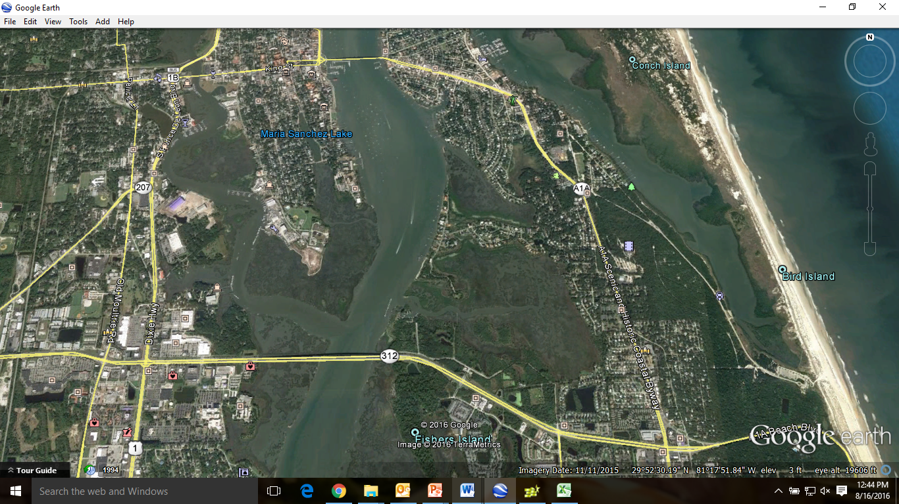
Map showing Scenic A1A coming south from the lighthouse property to Hwy 312 west to U.S. 1

Emergency Services

Primary emergency services are provided by the St. Augustine Police and Fire Department. St. Johns County Fire and Rescue Dept. provide the only medical paramedic services, and the St. Johns County Sheriff Department is well equipped, staffed, and excellent at providing additional support services to the police when needed, as well as being the primary law enforcement entity for the area. St. Johns County Emergency Management Operations Center is 10.3 miles west of the lighthouse.
Flagler Hospital, a 335-bed facility, is ranked in the top 5% of health care service providers in the country. A Med-Evac helicopter is based there working jointly with Jacksonville UF & Shands Trauma One Medical Center where a level 1 trauma center is located. Flagler Hospital also provides emergency services. It is located 4.5 miles southwest of the lighthouse just over the Hwy 312 ICW Bridge. Jacksonville is home to at least seven high-level health care facilities including but not limited to three Baptist hospitals as well as the Mayo Clinic.

A large soccer field at R.B. Hunt Elementary School, immediately southeast of the lighthouse property, provides an excellent helicopter landing area and has been used as such in the past. The St. Johns County Sheriff’s Dept. operates a helicopter, and the United States Coast Guard (USCG)has utilized the field in the past. The closest USCG air base is Station Savannah, GA, 150 miles north of St. Augustine. The Jacksonville, FL Naval Air Station is located on the west side of the St. Johns River 33 miles to the northwest of St. Augustine, FL.

St. Augustine is also home to the headquarters of the Florida National Guard, with offices and armories inside the city limits, and Camp Blanding, a joint training base for both Florida’s Army and Air National Guard is located 40 miles due west of the city.

As noted here, extensive emergency management resources exist in and around the Lighthouse property and the city of St. Augustine/St. Johns County area, and are available to respond to a wide variety of threats to both persons and property.

Communications

Communication is maintained on site between the tower, base of tower, Museum store, and office area at all times by staff members with high-band VHF radios. The Museum Services Director, Director of Facilities, and other management personnel, as well as maintenance personnel carry a radio at all times and they monitor conditions on site continuously. Telephone hard lines are used in the Museum Store (in the Visitors’ Center), office areas, Keepers’ Café (in Keepers’ House at base of tower), and US Coast Guard Barracks (on north side of Keepers’ House). Hard lines are the primary source of communication with local emergency services and the point of contact is the 911 Emergency Services Network.

All executive staff members carry cellular phones for use during events in case a loss of hard lines is experienced. Most regular staff members carry cellular phones and a telephone call tree is maintained for communications during an event or evacuation.

The Light Station property is a National Weather Service (NWS) Reporting Station. We are in communication with the NWS on a daily basis (NWS Storm Spotter classes have been conducted for staff members in the past and are taught periodically dependent on NWS staff availability).

Training

Training schedule of staff and volunteers is done every six months on emergency with sessions scheduled more frequently as new employees are brought into the company. The lighthouse Safety Officer is the Museum Services Director and responsible for providing the training. The current Safety Officer (18-year history with the company) is a licensed Registered Nurse in the State of Florida.

Levels of Emergency

Any emergency situation at the Museum must first be quickly evaluated and identified before decisions may be made for guiding action. In these cases, leaders will use the acronym IREM to guide those decisions and manage the event.

I – Identify the problem type: Level 1, Level 2, or Level 3?
R – Reaction Responses: Initiate and lead the proper response.
E – Evaluate Effectiveness: Monitoring of the event is on-going.
M – Make necessary adjustments: Return to E after each adjustment.

As indicated under I, there are three levels of problem type:

Level 1 – Minor: This is a local event with limited impact on the staff and site. It does not impact the overall functioning of the Museum. Planning and response is carried out at a limited, local level. The Disaster Plan would not be initiated, i.e., a guest faints on the grass outside the tower.

Level 2 – Emergency: This is a serious event that interrupts one or more functions of the Museum. Elements of the disaster plan would be initiated depending on the extent of the event, i.e., power loss, chemical leak, or heart attack in the tower.

Level 3 – Disaster: This is any major event that completely disrupts the operation of the Museum. The entire disaster/emergency management plan would be initiated, i.e., hurricane, fire, flood, active shooter on property, civil disturbance/riot on property.

Safety officers on property must make the determination of the situation following the IREM model and assign a level to the event quickly. This will determine initiation of the disaster/emergency management plan and what to do to ensure the safety of both guests and staff/volunteers at the Lighthouse.

Initiating the Disaster Plan

The overall operation of the site including its safety is the responsibility of the Museum’s Executive Director. She has hired, trained and delegated specialists’ in health and safety to help conduct emergency management procedures.
It is up to the Director of Museum Services to initiate the disaster/emergency management plan in consultation with the Executive Director (if time allows). In the absence of the Director of Museum Services the Executive Director may initiate, or assign another individual to do so. In the absence of both the Executive Director and the Director of Museum Services the authorized site manager may initiate emergency response procedures.

Currently, the Director of Museum Services serves as the Safety Officer for the organization. Second in the chain of command is the Director of Facilities, and below those two, any member of the Safety Committee may activate the plan in the absence of the first two officers. Below these, all staff members are trained in the working and implementing of the plan and refresher training is done quarterly.

The plan is broken down into action codes communicated to the staff on property depending on the nature and level of the emergency or disaster:

- Code Blue – Medical Emergency: No lockdown or evacuation

- Code Red – Fire, Bomb Threat, Hazardous Chemical Spill/Exposure: Evacuation

- Code Delta – Armed Subject(s), Riot/Civil Disturbance, Terrorist Attack outside the facility/property: Lockdown

- Code Alpha – Active Shooter inside the facility/property: Evacuate (Run, Hide, Fight protocol)

- Code Orange – Ordered by St. Johns County Emergency Services/Management to secure the facility: Lockdown

- Code Nemo – Missing Child: Lockdown

- Code Green – All Clear: Return to Normal Operations

The open nature of the Museum grounds present a physical environment that is very different from simply one building with multiple floors to manage in an emergency. As noted earlier, there are multiple buildings sitting on a 6.5 acre property that comprises the Museum. The property is essentially cut in half from east to west with a five-foot high aluminum fence that separates the paid visitor area with historic structures from the unpaid area comprising the parking lot and part of the north lawn areas which are all located on the east side of the property.
The historic areas are west of the three-foot fence and include the tower, keepers’ house, garage and Coast Guard barracks. A service entrance gate on the north side of the property is made of two large wooden gates that lock across the drive. The restored brick wall around the station proper is also only a visual barrier. The north and a small portion of the west side of the property can be entered simply by entering the woods of the maritime hammock, however it is a difficult foray through the dense undergrowth, thorns, and vines. The west and south sides of the property are bordered by a five-foot chain-link fence.

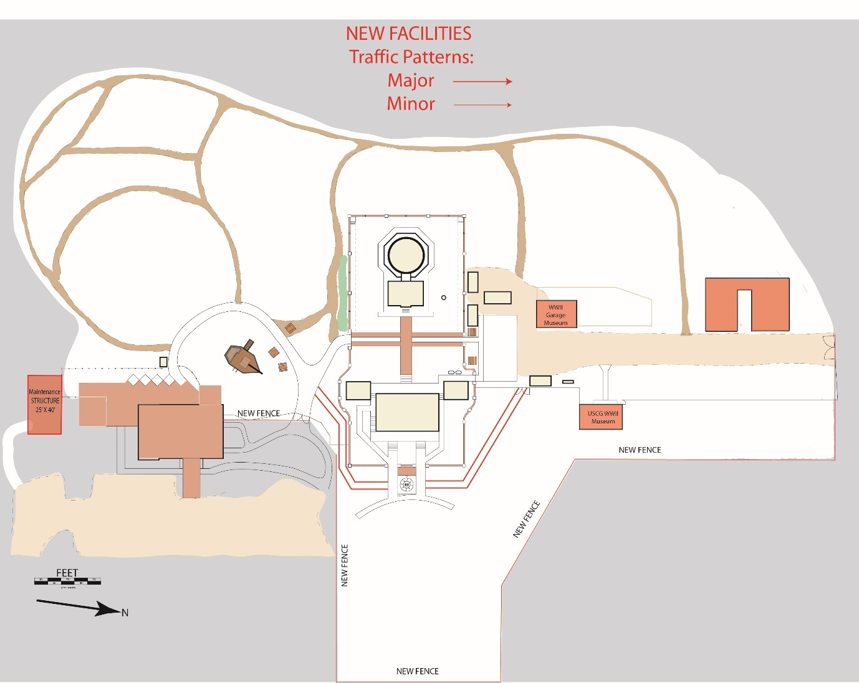
For orientation purposes, Red Cox Rd. would be at the bottom of the map (east), Carver St. and Lighthouse Ave. to the right (north), private housing to the top (west), and R.B. Hunt Elementary School to the left (south).

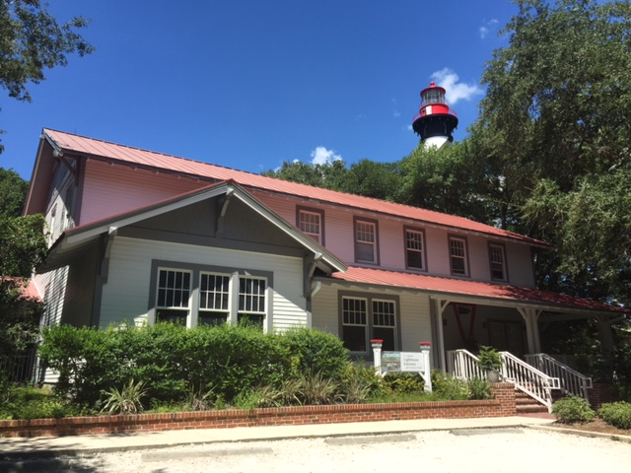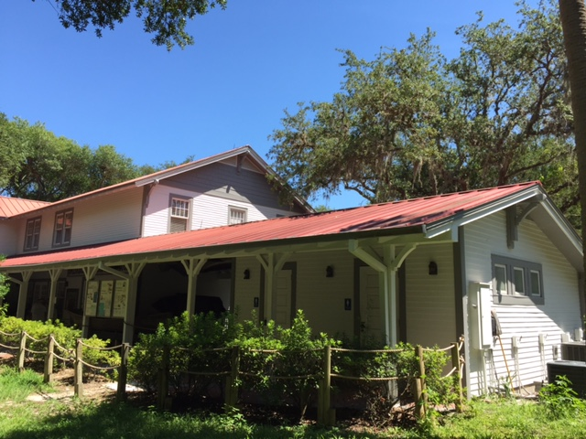
Visitors’ Center east side from parking lot main entrance Visitors’ Center west side with restrooms and breezeway

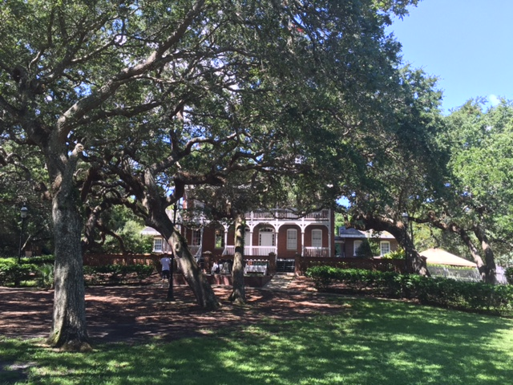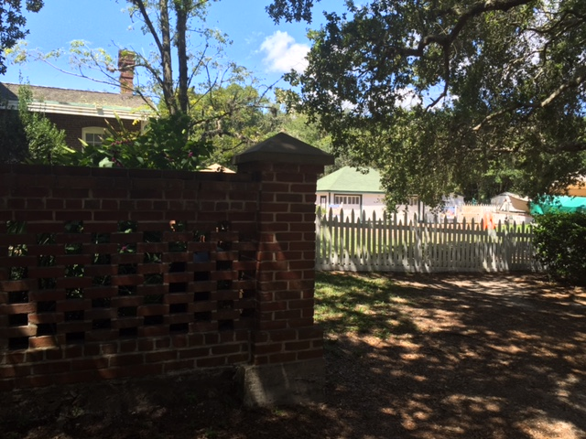
Keepers’ House east side from front lawn Detail of station courtyard wall

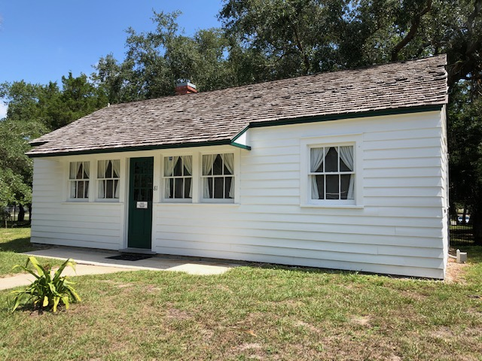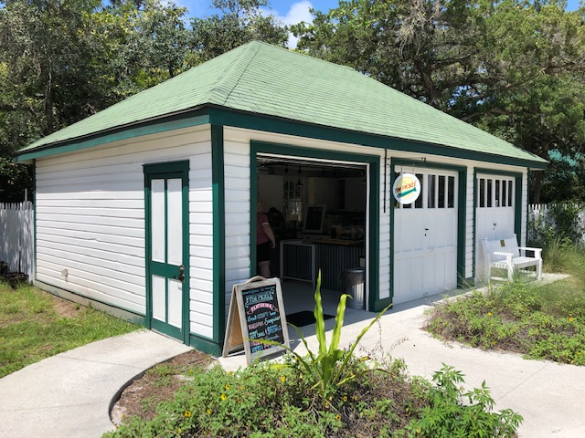
1942 USCG Barracks west side Tin Pickle (1936 Garage)

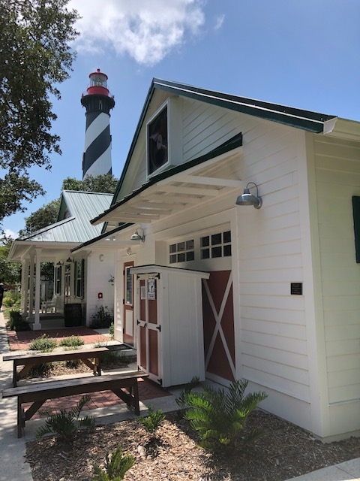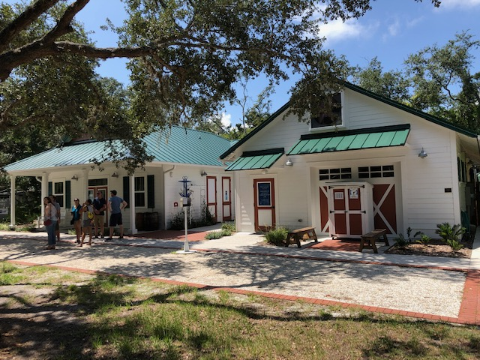
Maritime Center

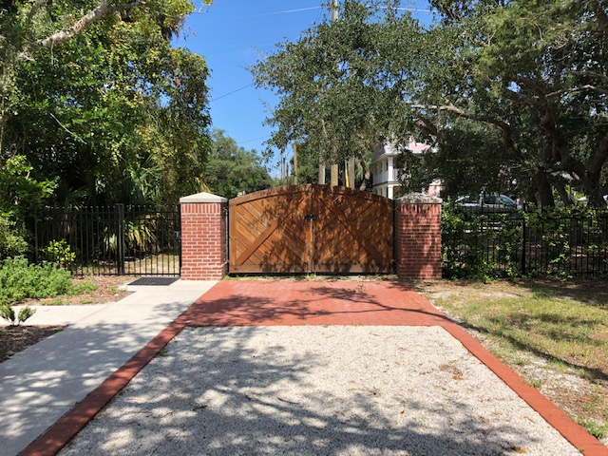
North Service entrance

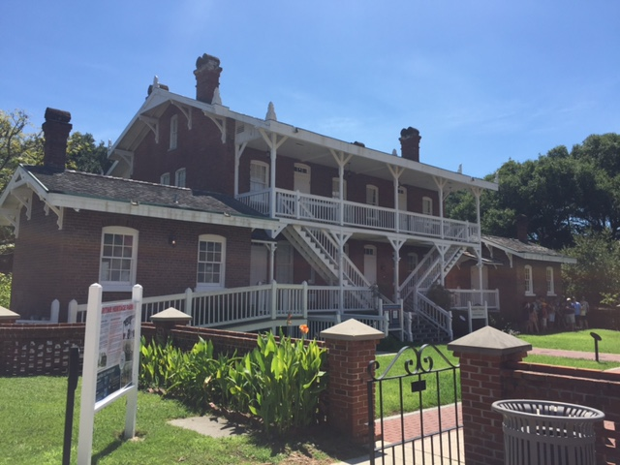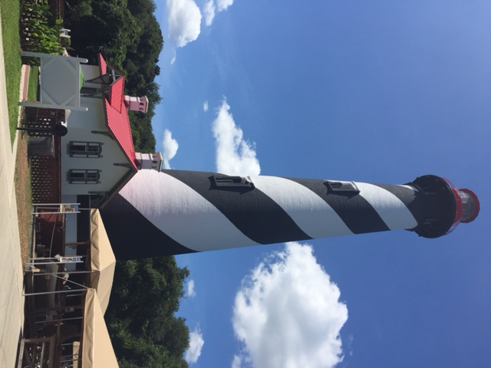
West side of keepers’ house from the north Lighthouse Tower from the northeast

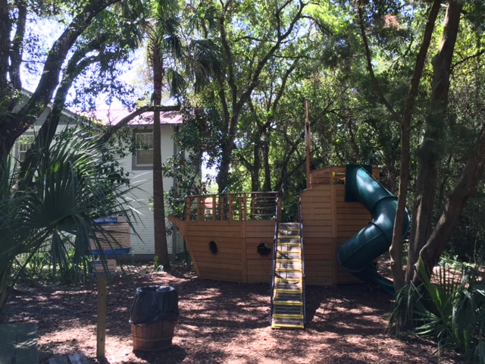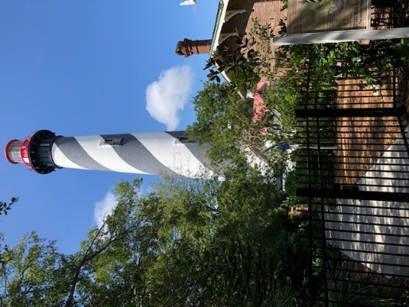
Children’s play area between Visitors’ Center and Keepers’ House with handicapped gate to parking lot

All codes will be initiated by radio communication across the site. The code will be called three times after which a location will be identified, i.e., “Code blue, code blue, code blue, Tower.” At that time the ranking safety officer will determine the action to protect staff members, volunteers and guests.

Another member of the management team will contact 911 emergency services immediately and standby on the phone with a radio to relay communication between emergency services and staff. All other staff members will act to guide guests to areas of safety and/or secure the site, doing sweeps of the property to ensure everyone is accounted for.

Codes will be prominently posted at all times, throughout all staff areas of the site for easy access, memory aides, and for new or training staff members and volunteers.

Lockdown – Code Black, Code Orange

Visitors’ Center - Retail staff will immediately monitor the east and west access doors to the Visitors’ Center as well as the stockroom door. Upstairs office staff will move to lock the north and south stairwell doors. One manager on duty from the upstairs office will proceed to clear the public restrooms on the back porch and move those individuals into the main Visitors’ Center building. All guests will be informed that there is a mandatory lockdown in effect, to stay down and move away from windows. If it becomes necessary to clear guests from the gift shop with its multiple windows, guests and staff should move upstairs to the office floor for cover.

Tower – Top of tower staff will secure the gallery deck, base of tower staff will secure tower door and Oil house window shutters. If time permits, individuals in the tower should be moved to the Keepers’ House. If not, guests and staff must shelter in the tower but be mindful of temperatures in the structure and monitor for symptoms of heat stroke.

Keepers’ House – Café worker moves to lock down keepers’ house and notify guests inside the structure. Must remember to check the restrooms.
USCG Barracks – Archaeology personnel will evacuate conservation area north of garage and shelter in the barracks.

Maintenance personnel will lock the garage and do a quick sweep of the nature trails in the maritime hammock then shelter in the closest building away from the threat bringing any guests they find with them.

Site will remain on lockdown until an all clear is received from emergency personnel which will then be communicated to the staff and guests.

Code Nemo: Same as above except that a sweep will occur first

In the case of a Code Nemo, management staff will need to monitor all individuals attempting to enter or leave the Visitors’ Center from the front porch. The site will be searched after a description of the child has been given. If no child is found after the first quick search of all structures, bathrooms and hiking trails, 911 emergency will be notified and the site will remain on lockdown until emergency services arrive.

*Please note that individuals may not be actively detained by anyone other than a commissioned law enforcement officer. In this case “lockdown” means observe and document the site access points until law enforcement arrives.

Global Pandemic/Medical Isolation – Any pandemic falls under a Code Orange scenario where government entities mandate closure of facilities, or the Executive Director makes the decision to close the facility for the protection of guests, staff, and volunteers from a highly contagious pathogen causing widespread illness and death. The organization’s management will secure the site from public visitation. After this, an evaluation must be made regarding the level of work that may be allowed to continue on property. All non-essential staff (those not maintaining the physical plant) should move to work from home and follow all St. Johns County Emergency Management, Florida Department of Health, Centers for Disease Control, and Federal Government guidelines of self-isolation, social distancing, human-to-human contact, and personal hygiene. Maintenance personnel will deep clean the physical site with use of personal protection equipment (PPE’s) to neutralize pathogen fomites on surfaces. In some cases, office workers may remain to clean their own personal work space and remain in the office as each pathogen presents differently and will require different levels of response. Any employee experiencing symptoms of the pathogen should move to immediately isolate from co-workers and family and seek medical direction for testing and care from St. Johns County Health Department or their local hospital. Administrative leaders will keep staff advised of available leave time, pay, and employment status. The Executive Director is the only person to communicate with the Board of Trustees on the status and operation of the organization. All communications with the public will be directed by the Executive Director through the Public Relations Department.

Active Shooter – Code Alpha:
When the code is called and the location is identified, evacuation will be ordered away from the threat.
Examples: If the threat is in the tower or Keepers’ House, i.e., the center of the property, the code will be called three times and then instructions to “evacuate north and south.” This means to evacuate out the north service entrance to Lighthouse Ave., and to evacuate south out of the parking lot to Red Cox Rd.

If the threat is identified “south” then instructions will be given to “Evacuate north,” at which time guests will be directed to evacuate out the service entrance to Lighthouse Ave. From there they can continue to White St. then west to Hwy. A1A.

If the threat is identified “North” then instructions will be given to “Evacuate South” at which time instructions will be given to evacuate through the main parking lot to Red Cox Rd. South to Hwy. A1A.

Anyone who cannot evacuate will need to exercise the “Run, Hide, Fight” scenario. Staff has been trained repeatedly in this scenario using resources of the Department of Homeland Security.

https://www.bing.com/videos/search?q=Run+Hide+Fight+Homeland+Security&&view=detail&mid=ADDC50F5BD5CDC5454AAADDC50F5BD5CDC5454AA&rvsmid=6A6C283E6AB6C68D6EFE6A6C283E6AB6C68D6EFE&fsscr=0&FORM=VDMCNL

Anyone unable to evacuate from the upper floor of the Visitors’ Center via the north and south stairways may evacuate out of the Administrative Assistant’s window onto the west roof, then proceed south down the roofline to the southeast corner of the bathrooms. From there it is only a five-foot drop to the ground (see attached floor plans).

Fire, bomb Threat or Hazardous Chemical Spill – Code Red
When the code is called, the fire alarm is activated, and the location identified, staff members will move to evacuate all staff, volunteers, and guests from the area. Team leaders, i.e., Safety Officer and Director of Facilities will ensure that all staff and guests are accounted for. All individuals will move to either the south rally point which is the St. Johns County Schools soccer field to the southeast of the property, or the St. Augustine City Boat Ramp parking lot and tennis courts to the east and northeast of the property. All guests and staff will remain at the rally points until St. Johns County Emergency Services have given the all clear.

Medical Emergency – Code Blue
When the code is called, and the location identified, one the staff member calling 911 will identify themselves over the radio and stand by to relay questions from the emergency responders to the staff member(s) working the code. 911 is called immediately. The Director of Museum Services, a trained registered nurse is dispatched to the scene, and if he or she is not available, the Executive Director is called, or the Manager on Duty.

One of the retail staff will go to the parking lot entrance on Red Cox Dr. to direct emergency services to the location of the emergency. There are two main locations for the fire truck to park: either into the parking lot in the front if located in the Visitors’ Center, or more usually to the Service Entrance gate at the end of Lighthouse Ave. if located at the Lighthouse tower or Keepers’ House.

Staff will close the tower if the emergency is in the tower, and base staff will station themselves on the walkway in front of the tower to make sure that the area remains clear until the emergency is handled. If the emergency is in another area, staff will close that area, or section and maintain other guests in an appropriate location away from the accident.

*The Museum Safety Officers maintain the operational status of AED’s and stock and supply first aid kits on a monthly basis.

All Clear – Code Green
All staff and volunteers return to normal operations.

Section 2 – Natural Disasters

Natural Disasters Primary Risk
- Water damage or flooding due to run off from the roof or breakdown of equipment.
- Fire, power outage, and equipment failure due to lightning strikes.
- Wind damage due to strong seasonal storms or micro-bursts.
- Hurricanes or tornadoes that accompany such systems.

Building Strength and Safety
Likely to Survive a Major Disaster:
- The Lighthouse Tower
- The Keepers’ House
- Visitors Center
- Maritime Center
- Maintenance Building

Unlikely to Survive:
- The 1936 Garage
- The 1942 United States Coast Guard Barracks (Coastal Watch Station WWII)

Priorities
- Human Life Comes First.
2. Collections and Historical Records.
(Harder to replace than office equipment.)
3. Computers, Files and Records.

Fire

Fire Prevention Rules
- No fires will be burned in fireplaces. This includes use of the Anastasia Gallery on the 2nd floor of the Keepers’ House, due to smoke traveling down the chimney and damaging the collections.
- Exterior burning, “living history” fires, or fires used in educational programs such as those in a kerosene lamp may be used only with staff in attendance.
- Staff who leave fires unattended for any reason are subject to immediate dismissal.
- Only dripless candles are allowed in any building.
- Smoking is not permitted at any time in or on any buildings or porches. Appropriate smoking areas have been designated for staff, behind the stock room and to the side of the Visitors Center. All smoking paraphernalia must be put out in designated Staff who smoke will do so in designated areas outside and away from buildings and the public. Staff will not smoke while in buildings or on the job.
- Stock, supplies, or collections will not be stored or block the clear pathway to any breaker panel or exit.
- Doors shall remain unlocked from the inside at all times, unless in the case of a Code Black, Blue or Orange when human life is at stake and lockdown is enforced.

Location of breakers
Keepers’ House
Closet in Restrooms: AC/Heat for all Museum.
Closet in SW Parlor: General and all lights.

Lighthouse Tower
Oil Room on southwest wall.

US Coast Guard Barracks
Northeast corner outside of building

Visitors’ Center
Electrical room – south end of building, access from outside, sidewalk between Visitors’ Center and restrooms. Main switch located south of restrooms where picket fence intersects the property line.

Collections Building
East wall near back door.

Date of Last Electrical Inspection
Burchfield Electric: 829-5735 May 2006
*Upgrades to Coast Guard Barracks and Garage 2009 & 2017

Date of Last Drop in Fire Inspection by Fire Marshall
St. Johns County Fire Dept.: 823-2526 July 2012
St. Johns County Fire Dept walk-through Twice per year

Fire Alarm System Inspection and Upgrades
Atlantic Security: (904) 743-8444 April 25, 2019

Fire Extinguishers
Date last checked: July 2021
Who to call: Firemaster 800-522-7150

*The Museum Safety Officers maintain the operational status of Fire extinguishers on a yearly basis.

Location:

Keepers’ House
- Basement of Museum (opposite cisterns)
- Upstairs Museum (by Exit door)
- Gallery Upstairs (by Exit door)
- Kitchen (on cabinet above dishwasher)
- Bathrooms (by entrance)

Lighthouse
- Watch room (on desk)
- Oil Room (to the left as you enter)
- Lens Room (on left as you enter)

US Coast Guard Barracks
- Next to door (to the right as you enter)

Tin Pickle
- Next to main doors (south side of main garage door and next to walking door)

Maintenance Building
- Next to door (to the left as you enter)
- West storage room (to the left as you enter)

Visitors’ Center
- Main Floor – Store stock room (to the right as you enter from store)
- Second Floor – Next to south stairwell exit (across from Receptionist’s desk)

Maritime Center
- Main education room (left of main double doors)
- Dry lab (left of main double doors)
- Wet lab (right of north door)

Collections Building
- Front Door
- Back Door

Fire Panel Boxes
Keepers’ House
- Inside closet in the Assistant Keeper’s parlor.

Coast Guard Barracks & Tin Pickle
- Connected wireless to the maritime center

Visitors’ Center
- Ground floor, south stairwell, to the right as you exit

Maritime Center
- Center utility closet, on left as you enter outer door

Maintenance Building
- North wall of main room, on left as you enter north door

Collections Building
- Back door

Power Outage/Lightning Strike

Power Outage
- Staff on site calm visitors and escort them out of the basement in the Keeper’s House through the fire escape stairs which are straight, and because the door when opened offers light into the basement area.
- Visitors are removed from the tower and the tower is closed if lightning is in the area. Well before a strike.
- Emergency lights come on.( Most power outages are temporary.)
- Office staff should power down computers to protect from surges.
- Flashlights are located with first aid kits.
- Highest-ranking supervisor on site assesses the situation to determine if the site will remain open. Is the site safe? Do we have a cellular phone to communicate in case of emergency?
- To operate store purchases manually, use key located in cabinet beneath cash registers, to unlock drawer. Record UPC codes, quantity and price of items purchased.

When Lightning Strikes
- Calm any guests on site.
- Turn off circuit breakers (see building floor plans)
- Staff on site. Do a sweep of the buildings to determine any damage and the extent of same.
- Call non-emergency Fire Dept. if no fire and alarms are sounding.
- Call alarm company to turn off alarms
- Turn off air conditioners in Garage, Collections Hut, and Coast Guard Barracks
- Call on-call electrician if light out or lens has stopped turning (see on-call mechanic
- Power down and unplug all computers
- Make sure everything is locked up
- Notify Staff Managers and Directors of situation
- Do not talk to reporters. Refer them to the Executive Director
- Notify staff coming in early the following day of the situation, and make reports to insurance of any damage.

Flooding
A flood is most likely to occur in the basement of the Keepers’ House.
- The public should not be allowed into a flooded area. Block off this area with caution/wet floor signs.
- Do not use electrical systems in a flooded area.
Do not step in water that you suspect may have reached an electrical socket and/or powercords. Turn off power to the basement in the breaker box located in the closet of the SW Parlor on the main floor of the Museum. You may also turn off the power in the main breaker box located in the public restrooms in the center closet.
- Clean up water and mud as quickly as possible. A sump pump may be necessary for very deep water.
- Fill out an Incident Report about the flooded areas.
- Contact the Chief Curator, Collections Manager, and the Archaeological Conservator to access damage to collections. Specialists may be identified and contacted afterwards. Film/photograph any damage. Photograph damage using Museum camera (see Marketing Director) or sign out disposable camera from store. Video damage using video camera found in supply closet – upstairs of administration building.

Hurricane

A Hurricane causes Museum staff to deal with many types of disaster at one time. Remember our priorities.

- Human Life Comes First.
- Collections and Historical Record. (Harder to replace than office equipment)
- Computers, Files, and Records.

*Please note that all residents and business operators on the island will need to obtain a return pass from the police department prior to an evacuation in order to return to the island after an evacuation.

Hurricane Preparation

Survival Kit: Safety Committee
Kept in Maintenance Garage under workbench. In May, inventory survival kits using a copy of checklist found in this section. Return signed and completed checklist to this plan.
Last completed inventory: May 2016.

Packing Supplies: Safety Committee
Plastic Containers, duct tape, scissors, markers, small legal pads, pencils (kept in storage unit). Conservator has screwdriver for exhibit cases in filing cabinet with cleaning supplies. In May, inventory all packing supplies using a copy of checklist found in this section. Return signed and completed checklist to this plan.

Filming of Site: Chief Curator
A video of the site should be made at least once per year in May, more often if significant changes have occurred at the site. Completed video should be dated and given to Deputy Director to be stored in both Safe Deposit Box for record-keeping purposes. Also, sign and date checklist in this plan.

Office Preparedness: Comptroller
Three times a year (January, May, September) back up all data and transfer these back-up drives to Director of Finance for storage in Safe Deposit Box, Harbor Bank, Anastasia Island – St. Augustine, Florida. This is a good time to make a copy of the insurance records, leases and other materials. Also, sign and date checklist in this plan.
Last Back up: Weekly

Window Preparation: Maintenance Staff/ Director of Facilities.
- Precut plywood boards. Paint each board front and back to keep from warping and label them as to where (which window) they fit. These will be stored in the Maintenance Garage or in off-site storage, so that they do not warp.
- Pre-drill holes for these boards. Screws stored on shelf behind workbench.
In May, check to make sure all boards and screws are accounted for and in good condition. Sign and date checklist in this plan. When evacuation is called of the local area, put the boards up in the appropriate windows.

Hurricane Evacuation Ordered

Hurricane Supervisor: Executive Director, Associate Director, Director of Museum Services,
Chief Curator, Archaeological Conservator, or the next highest-ranking manager on site.

Staff members are routinely advised to make their own personal hurricane plans for their family early on each season. All staff are expected to report for Hurricane preparedness if an evacuation of the island is closed, with everyone working together the time to set up the site is only 4-5 hours total.

Immediately following the call for evacuation by local officials All staff will meet at command central in the base of the Lighthouse tower to sign in and give location and phone number of where they are evacuating or cellular phone number. Hurricane Supervisor (H. S.) will assign staff to a team (Grounds, Collections, or Records). When First Priority duties are complete, staff will report to command central, H.S. to check-off what is completed and direct staff to next assignment. Note: All First Priorities should be completed before moving on to any Second Priority.

- Command Central will be at steps at the base of the Lighthouse.
- Staff will be released after the below duties are performed.
- Everyone is in charge of his/her own area.

Grounds

Survival Kits: Safety Committee
Upon hurricane warning and evacuation notice, move the survival kit into the tower, first landing. Move clean water to this area and sump pump and battery pack. Leave a pathway for access to the light.

Boarding Up the Site: Maintenance Personnel, Director and staff on site, especially Chair of the Safety Committee.

Boarding up of the Site should occur first on the buildings most likely to survive and then on the outbuildings:

Keepers’ House: Boards cut for upstairs windows to be installed inside by using a ladder.
- Tower: throw hurricane latches, close shutters.
- Visitors’ Center
- US Coast Guard Barracks
- Tin Pickle (1936 Garage)
- MAEC – Hurricane windows installed, no boards necessary
- Maintenance building – Hurricane windows installed, no boards necessary

Grounds: Director of Facilities and Maintenance, Staff on site

Remove any objects that might act as projectiles (i.e. planters, chairs, umbrellas, etc.). Move all benches, tables, into the garage, or inside the closest building.

Collections

Collections: Chief Curator, Collections Manager, Director of Conservation, staff on site

The Museum has five First Priorities:
1. Original Lighthouse artifacts that are original to the site and the families
2. Artifacts located in the Keepers’ House basement
3. The original artwork,
4. The keeper’s office in the tower,
5. Permanent, temporary or traveling exhibits.

The Chief Curator will be in charge of all activities and will bring supplies, or assign staff to pick up needed supplies. Check in with him for your instructions inside the Keepers’ House. Use gloves when handling artifacts and carry only one at a time. Plan your route in advance avoiding tripping hazards

The tower is the strongest and most wind resistant of our structures. Because of this we move all priority objects once packaged into the tower and move them to the highest of the eight landings possible. Once there they are covered in plastic to prevent rain that blows in from wetting them.

Staff Instructions:

If wrapping large exhibits or objects in plastic, move them away from windows first. Be careful not to put tape on the exhibit or object. Make sure at least two people are handling the heavy or awkward boxes during the move. Stack containers neatly and cover with plastic.

The Chief Curator will decide where to move and store the collection, i.e., Tower or Visitor’s Center. See appendix for handling of special objects.

Once finished with all First Priority begin Second Priority. Once again, start in the basement and move up. If time allows, pack the rest of the objects in the cases in the basement. Place these in containers using the same guidelines as First Priority objects. If time is short, replace the exhibit case covers and put them as high as possible and away from doors and windows in case the basement floods.

If time allows, the Museum has a Third Priority. These are objects that are not artifacts, but may be props or furnishings purchased for the house. Save these last, or wrap in plastic If time does not allow for them to be moved to the tower, put them as high as possible. If possible, cover the text panels and the two exhibit “scrapbooks” with plastic.

Areas of Responsibility

Collections Building:
Jason Titcomb, Chief Curator
Barbara Holland, Collections Manager

The Collections Building Is located at 1704 Lakeside Dr., Suite 6, St. Augustine. It contains many precious artifact and objects, including originals for the archives (Special Collections). The Collections Building is on higher ground than the Light Station site, and may not flood. However, precautions should be taken if nearby retention ponds overflow.

If the objects are boxed, wrap the boxes in plastic or place in plastic tub. Larger objects will need to be wrapped in plastic. Make sure you do not tape the plastic to the box or the object.

All objects will be covered in plastic on the shelf they are on. Cover the map case and all shelving units that still have objects with plastic. Tape the plastic around the bottom of the shelving unit. Cover all freestanding objects with plastic. Be careful not to put tape on the object.

Archives and Other Collections:
Barbara Holland, Collections Manager

In the offsite Collections building, located at ADDRESS, there are four First Priorities:
- The archives
- The library
- The archivist’s and curator’s files
- Collected objects

Obtain containers in advance from non-collection storage units and store them for use in the collections Building. Containers are stackable and don’t take up very much room. They may be in short supply during an emergency.

Use gloves when handling artifacts and objects. Make sure at least two people are handling the heavy boxes during the move.

Plan your move route in advance and make sure it is free from debris or trip hazards. Stack containers neatly in the southwest corner of the room and cover them with plastic.

- Records management material is located in the second drawer of the filing cabinet to the left of the archivist’s desk. Place all material in a container.
- The only part of the library that needs to be packed is the reference books/material. These are located in the small bookcase behind the Archivist’s desk.
- The archival files need to be placed in containers. Be careful not to put too much into a container, you should be able to lift it safely.
  - Archival records located in the large file cabinet need to be placed in Rubbermaid containers (container).
  - The Archivist’s files are located in the third drawer of the filing cabinet to the left of the archivist’s desk.
  - The Curator’s files are in the top three drawers of the filing cabinet behind the Curator’s desk.
  - The Exhibition files in the bottom two drawers of the center filing cabinet in the education closet also need to be put in containers.
  - All disks on the archivist and curator’s desks also need to be placed in the containers with the files.
- There are many miscellaneous collected objects that need to be put in containers. All objects on the shelves between the two desks and any objects on the table next to the closet need to be put in containers. Carefully wrap all objects in acid-free tissue paper (located on the roll rack in the Collections office). Place heavier and less fragile objects on the bottom.

Once finished securing objects, unplug all electrical equipment and secure the facility prior to leaving.

Conservation Lab:
Starr Cox, Director of Archaeological Conservation
Andrew Thomson, Archaeological Conservator
Dorothy Rowland, Assistant Conservator

The conservation lab contains many irreplaceable artifacts and objects. Many of these will be waterlogged items. These objects need to be secured to prevent damage or loss, but there is not a priority for keeping them dry.
- Small artifacts in solution/containers need to be packaged together and moved into to the sink. These objects are most often found on or above the sink. The shelved items in the window need a strip of duct tape run vertically to secure the shelves in place.
- Artifacts located in the containers on the large metal shelving can shelter in place. Make sure all lids are securely locked, and if any container is light in weight either fill it with water or weight the container with dive weights.
- Artifacts located in containers on the floor can also shelter in place. Follow the same precautions listed above.
- Items in the oven may remain in the oven. Care needs to be taken to ensure the oven is turned off and unplugged. The oven doors should also be secured with zip ties.

All of the above are likely to be in a chemical solution. The chemicals in the sealed containers can be hazardous. Ensure proper OSHA Globally Harmonized System of Classification (GHS) labeling is placed on the container and personal protective devices (PPD’s) are used when handling.

There will also be artifacts that have completed conservation which are in the process of transitioning to the collections facility. These objects need to be secured and kept dry. They must be put in designated plastic storage containers and stored off the floor in either the conservation office or the x-ray room. These objects can be found in the conservation office. In addition to these objects, there may be dry (yet still undergoing conservation) objects stored on the bakers rack next to the garage door. The bakers rack should be covered in plastic and rolled into the x-ray room.

The conservation files in the filing cabinet cannot be replaced, and so should be placed inside a designated plastic storage container, and moved to the top of the conservation office desk. Also include the SDS binder in the container. If the lab is badly damaged, we will want to know what chemicals we may be exposed to at the time of recovery.

Place all loose chemicals in the fire cabinet and lock it. Ensure all containers are clearly marked with GHS labels prior to placing in fire cabinet. There is a second fire cabinet in the corner next to the garage door that is used for dehydration. These items may also shelter in place, and the cabinet needs to be locked. A pre-cut length of wood should also be run through the acid cabinet handles to secure chemical stored within.

If there is time, unplug all appliances and move smaller ones to the storage closet next to the x-ray room. All small loose items should also be secured.

The Corral (Outdoor storage/work/conservation area):
Starr Cox, Director of Archaeological Conservation
Andrew Thomson, Archaeological Conservator
Dorothy Rowland, Assistant Conservator

Wet artifacts in vats may stay in the vats, but any lids need to be secured. Ratchet straps for this purpose are stored in the conservation storage closet. Loose objects need to be stored in either the lab or secured within the sheds in the corral. Objects in ER need to be turned off, and disconnected. If they are small such as the objects in the tall garden shed, they should be placed with their solution into sealable containers and secured in their current cabinet. The logfish vat tent needs the top taken down and stored inside a secured cabinet. As long as all sheds are secured, the power supplies may shelter in place, but the must be disconnected and unplugged. All buckets/lids and artifacts currently residing in the dive corral are to be moved inside the lab and follow the procedures in the above section.

Maritime Archaeology:
Chuck Meide, Director of Archaeology Division
Airielle Cathers, Dive Safety Officer
Nicholas Budsberg, Archaeology Admin. Director

First Priority: Remove (place in plastic bags) files, rolled drawings, and all records from the Archaeology Building and move to the tower. Remove (place in plastic bags) all artifacts, lap top computer, tools, and compressor. Move all chemicals to Flammables Cabinets provided. . Remove books and reports.
Second Priority: If time allows, remove drafting supplies, drafting film and rolls from the Archaeology Building. Move datum’s from outside the Archaeology Building to inside the building.
Lock windows and close blinds. Unplug all electrical equipment and secure the building when leaving.
Assist others on site with boarding up the windows of the Archaeological offices and lab areas.

Financial:
Lee Capitano, Director of Finances and Retail
Susan Mills, Comptroller
Darlene Humphreys, Bookkeeper

First Priority: Remove all important documents from the current fiscal year. Make a back up disc if one has not been done recently of all Peachtree financial records. Remove all personnel and and compliance records, documents, leases, operating licenses, bank statements, back up computer (Peachtree), insurance records, double check with Collections Staff to make sure that insurance records are removed.
Lock windows and close blinds. Unplug all electrical equipment and secure the building prior to leaving.
Second Priority: Remove file drawer; store 2014-15, Museum 2014-15, and receipts 14-15.

Administration:
Kathy Fleming, Executive Director
Martin Corlieto, Associate Director
Jay Smith, Office Manager
Cheyenne Genovar, Human Resources Coordinator

First Priority: Back up hard disk drives on Executive Director’s, Associate Director’s, Executive Assistant and other staff computers and take the disks with you. Gather the following: personnel files, grant files, board notebooks, long-range plans, compliance documents, and Plan of Action. Place all of these items in plastic boxes and take to the tower.
Lock windows and close blinds. Unplug all electrical equipment and secure the building prior to leaving.

Operations:
Rick Cain, Director of Museum Services
Jason Smith, Facilities Supervisor
David Popp, Maintenance
Jim Brestle, Maintenance

Primary oversight of the Grounds Team and volunteer communications. Board up the windows, secure all loose objects on the grounds, monitor power and water systems. Collect operations files into water tight tubs and move to tower. Do a final check of all buildings prior to securing the property.

Important: The Operations team is also responsible for having materials available for the use of all departments prior to the evacuation, this includes watertight plastic tubs, plastic sheeting, and hand trucks or carts.

Development:

First Priority: Back-up computer (Paradigm – Donor Program), take program and software disks. Box up files in credenza, press clippings and binder notebook on bottom shelf on bookcase. Back up volunteer computer files, remove discs and software discs. Remove all volunteer files, pack with computer discs and move to tower.
Lock windows and close blinds. Unplug all electrical equipment and secure the building prior to leaving.

Marketing/Membership:

First Priority: Back-up computer, remove box of diskettes and zip disks, and take with you. Be sure to back-up Past Perfect program on both PR and staff computer for membership and mailing lists. Take program software for PastPerfect, Quark. Gather photographs, negative, slides and files (press clippings, press releases, membership data envelopes, guest register recap book, coupon usage folder, advertising budget and breakdown of accounts) and rolodex. Remove the above mentioned items, place in plastic box.
Lock windows and close blinds. Unplug all electrical equipment and secure the building prior to leaving.

Retail:
Lee Capitano, Director of Finance
Sam Andrews, Gift Shop Manager
Elizabeth Balog, Assistant Gift Shop Manager
All Front Line Staff

First Priority: Remove all cash. Count and give to authorized staff person to deposit in bank. Remove all items from walls or tops of shelves and place on floor. Cover Cash Registers with plastic and tape securely.
Second Priority: Make sure all electrical equipment on site is unplugged.
Third Priority: Move store stock last. It can be replaced.
Lock windows and close blinds. Unplug all electrical equipment and secure the building prior to leaving.

Interpretation:
Gayle Ballard, Director of Interpretations
Jill Titcomb, Education and Program Manager
John Clarke, Maritime Activities Coordinator
Amanda Dixon, Volunteer Manager

First Priority: Back up Vista on Director of Education computer and take with you. Remove all education files from education office area. Remove education record binders from walk-in closet (in file cabinets) and education cupboard (far leftover long counter) and kitchen, and. Place computer disks in respective file boxes.
Second Priority: Remove specialty tour boxes from storage under public stairwell in visitor’s center and place in tower; pack library, Director of Education’s files, and school tour files, in plastic containers and place in tower.

All Staff: Unplug all electrical equipment, ensure windows are locked, close window shades.

After the Disaster

Staff will return to work on the same day that schools reopen for a full and regular schedule unless otherwise notified by cell phone. Keep your cell phone charged and with you. Oftentimes this is a day or two following a major disaster.

Those living on the island will need resident passes to get back onto the island. These are available from the local police department prior to the disaster.

The Executive Director, Deputy Director, Director of Operations, or their appointee will try to visit the site as soon as possible to determine conditions and status. They will communicate with each other to form a plan for staff and take appropriate action after the disaster.

If telephone service is working, the Executive Director, Associate Director, or Director of Museum Services will contact staff to give an idea of when to return to work.

All staff will report to work on the first day back. Generally, disasters cause staff to be lost to their own concerns. Some may not be able to travel or to return right away. Therefore, if you are stuck make every attempt to contact your manager. Be advised that schedules may be reworked or reset and you may be needed to assist with additional shifts of cover those that can’t make it. Everyone should be prepared to do whatever is needed to help out.

Section 3 - Recovery

Recovery is the process of digging out of a disaster and making the Museum run again.
Because people come to see the tower and because the tower is likely to survive, the chance for recovery of the Museum is strong.

Staff will meet at command central at the stairs at the base of the Lighthouse.
When you are on site, watch for:

- Downed power lines.
- Broken glass, nails or debris.
- Rodents or snakes, reptiles or lost pets
- Standing water. BEWARE OF ELECTRIC SHOCK.

Executive Director or highest-ranking manager on site will assess damage, make notations in notebooks as to status of collections and grounds.

1. Locate the survival kits in the tower.

2. Call for status on electrical service and water:
Phone: FP&L 1-800-226-3545
Account #: 71445-01538

Phone: City of St. Augustine Water 825-1037
Account #: 36-29200-19-5

3. Film/Photograph:
Our first point of business will be to film or photograph and then clean up.

Insurance is provided by Herbie Wiles Insurance Company: 829-2201

4. Remove all plastic coverings if possible and given that items underneath will be safe from weather.

5. Extra Help:
Board members and volunteers may be able to help during an emergency either with preparation or clean up.
6. Everyone helps task after a tropical storm is raking debris and limbs from the parking lot.

Artifact survival/recovery team will be led by our Chief Curator Jason Titcomb and his staff. Outside help from outside the area may also be needed.

Portable toilets may be provided by Moore’s Sand and Septic: 904 824-8939

Director of Facilities to call ahead and secure these services in advance and have them on call.

- D. Davis Construction: 904 824-3533

Important Phone Numbers

If Light Out, call Birchfield Electric 829-5735
If mechanism stops, call On-Call Mechanic Brian Wood 904-377-4698
(*Mechanic does not have keys so staff must give access)

Emergency 911
St. Augustine Police (non-emergency) 904-825-1070
St. Augustine Fire Department (non-emergency) 904-825-1098
Internet and Phones – Comcast 904-615-6946
Windstream 877-621-6666(877) 621-6666 ((877) 621
Mike Horner – internal phones 904-329-6656
Computers – BoxMeta 904-229-0922
Fire and Burgler Alarms - Atlantic Security 904-743-8444
Florida Power and Light acct #71445-01538 1-800 226-3545
Herbie Wiles Insurance Co. 904-829-2201
Burchfield Electric 904-829-5735
City of St. Augustine Water Acct #36-29299-19-5 904-825-1037
USCG Aids to Navigation Team (ANT) Jax. Ops. Center 904-247-7311

Section 4 - Checklists
Survival Checklist

Survival Kit (in garage under workbench)

- Two large plastic tubs each with the following items.
- Nitrile gloves, five pair
- Work gloves, two pair
- Rubber boots, one pair
- First aid kits, with snake bite kit
- Cameras. Three (check expiration dates annually)
- Wipes for dusting
- Extra plastic covering
- Hard hats, two
- Particle masks
- Silicone
- Tool kit: Hammer and two sizes of nails. Screws and screwdriver. Pliers, Swiss army knife. Small saw, etc.
- Permanent markers
- Flashlight and batteries (new batteries each hurricane season)
- A copy of this plan
- Small notebook
- Copy of insurance papers
- Disposable baby wipes. (replace annually)
- Kleenex
- Small Carbon dioxide Fire Extinguisher
- Insect repellant
- Clorox, small bottle for water purification
- Safety goggles, two pair
- Sump pump (check annually)
- Drinking water: 5 gallons (replace annually)
- Garbage cans, three
- Chain saw and fuel
- Caution tape

___________________ ________________________________
Date Signature

Packing Supplies Checklist

- Plastic Containers (30)
Museum
Conservation Hut
Archives and Other Collections
Maritime Archaeology
Financial
Operations
Public Relations/Development
Membership
Education/Volunteers
Store
- Duct Tape (5 rolls)
- Small Legal Pads (5)
- Markers (1 box)
- Pencils (1 box sharpened)
- Acid Free Tissue paper
- Heavy Duty Scissors
- White cotton artifact Gloves
- Plastic Bags
- Plastic Sheeting

May __________________________ ___________________
Date Signature

Hurricane Preparation Checklist

Filming of Site
- Digital recording of all buildings and grounds
- Give recording to Director of Operations for storage in safe deposit boxes

May ___________________ __________________________
Date Signature

Office Preparedness
- Back up all data
- Put in Safe Deposit Boxes

May ___________________ __________________________
Date Signature

Window Preparation
- Boards located and in good condition
- Screws located
May ___________________ __________________________
Date Signature
MASTER PLAN
HURRICANE SUPERVISOR

Grounds Team Collections Team Records Team

___________________ ___________________ __________________
___________________ ___________________ __________________
___________________ ___________________ __________________
___________________ ___________________ __________________
___________________ ___________________ __________________
___________________ ___________________ __________________
___________________ ___________________ __________________

Survival Kit Keeper’s House Financial
__ Priority 1 __ Priority 1
Boarding Up __ Priority 2 __ Priority 2
__ Keepers’ House __ Priority 3
__ Visitors’ Center Archives
__ Coast Guard Barracks Collections Building __ Priority 1
__ Tower (throw latches) __ Priority 1 __ Priority 2
__ Keepers’ Office __ Priority 2
(close drawers, doors) Operations
Maritime Archaeology __ Priority 1
Grounds __ Priority 1 __ Priority 2
__ Priority 1 __ Priority 2
Development
__ Priority 1
__ Priority 2

Membership/Advertising
__ Priority 1
__ Priority 2

Store
__ Priority 1
__ Priority 2

Education
__ Priority 1
__ Priority 2
__ Priority 3

Appendix A – Floor Plans with Emergency Exits

Lighthouse Tower

N
Lens Room ROOmRoRoomRooroom

Watch Room

Fire Extinguisher
Oil Room
Keepers’
Office
First Aid Kit
Circuit Breakers

Exits

The tower has three primary exits. Two window exits onto the raised base of the tower foundation in the hallway connecting the oil house to the tower, and the front door. There are two windows each in the oil room and the keepers’ office which may be used as well.

Keepers’ House

Fire Extinguisher Circuit Breakers Exits
First Aid Kit Fire Panel Box N

The Keepers’ House has three floors. The upper floor (Gallery) is a large, open meeting room with four exits onto the east and west porches. One exterior stair on the south and east side and two stairs on the west side provide egress to the ground.
The main floor has six doors on east and west sides and a circular stair to the basement which has one exterior door to the west tower courtyard.

Gallery Upper Floor
Main Floor

Circular stair to basement

Kitchen Restrooms

Basement

Circular Stair to main floor

Hallway
The basement has two large water cisterns occupying the center of the structure that are inaccessible to staff and guests. One hallway on the west side leads from the circular stair to the exit.

Visitors’ Center
*Note that the upper level of the Visitors’ Center may be evacuated out the west office windows onto a wide, low roof, then to the southeast corner of the roof line where it is only a 5-foot drop to the ground.

Fire Extinguisher

First Aid Kit

Circuit Breakers
N
Fire Panel Box

Exit
ENTRY

STAIR
MAIN FLOOR
STORE

STORE
ROOM

Stair
STAIR

Office Office Office Office Office

UPPER FLOOR

STAIR

U S Coast Guard Barracks, Tin Pickle

Fire Extinguisher

First Aid Kit N

Circuit Breakers

Fire Panel box

Exit

Office

Coast Guard Barracks

Tin Pickle
Office Office

Maritime Center

Fire Extinguisher

First Aid Kit W

Circuit Breakers

Fire Panel box

Exit

Dry Lab X-Ray

Maritime Center Wet Lab

Maintenance Building

Fire Extinguisher

First Aid Kit W

Circuit Breakers

Fire Panel box

Exit

Appendix B – Emergency Phone Tree

*Emergency phone tree is maintained by the Safety Officer and HR Director in a separate document to protect employee privacy. It is constantly updated with staff changes and utilized if an evacuation is ordered.

Appendix C – Lightning Policy/Guidelines

Lightning Policy

The staff person at the top of the tower makes the decision about when to close, based on all of the accurate information available to him/her.

Closing the tower while the sun is still shining and/or the storm is not readily apparent may require more discussion and explanation with our guests. Expect this and be prepared. Closing the tower late may mean taking unnecessary risks. Our goal is to close at the appropriate time for everyone’s safety and understanding.

When the tower is closed because of lightning, guests should not be allowed to remain in the tower yard or at the base of the tower. Guests should be on the keepers’ house porch, inside the building, or on their way back to the VC.

Staff members are encouraged to learn as much as possible about weather and thunderstorms, their movements and safety precautions. Discuss your new findings with each other and with guests on a continual basis. Also, learn more about the tower, its structure and the protection it offers from lightning (if any).

As you make your decision about the weather, use all of the accurate information you can gather about lightning. Please feel free to discuss your decision with other staff, or get a second or third opinion if you would like. We’ll be meeting with Ray Hamel, a trained weatherman and a USCG certified boat captain, to discuss thunderstorms and reading radar.

Please make sure that what you are hearing is really thunder and not cannon fire, a dump truck or a vehicle backfiring, or any other loud rumbling noise. Ask another staff person to come out and listen with you if you are unsure and it doesn’t look like a storm is in the vicinity. Hearing thunder is one indicator of trouble and should be taken seriously. Radar may be checked, but it only shows precipitation and should not be used exclusively. Lightning tracking websites may not be timely, so double-check their timeliness.

Please be respectful of other staff persons who may be more hesitant and cautious than you. Do not force any frightened person to remain at their post.

This is effective today, August 22, 2003.

