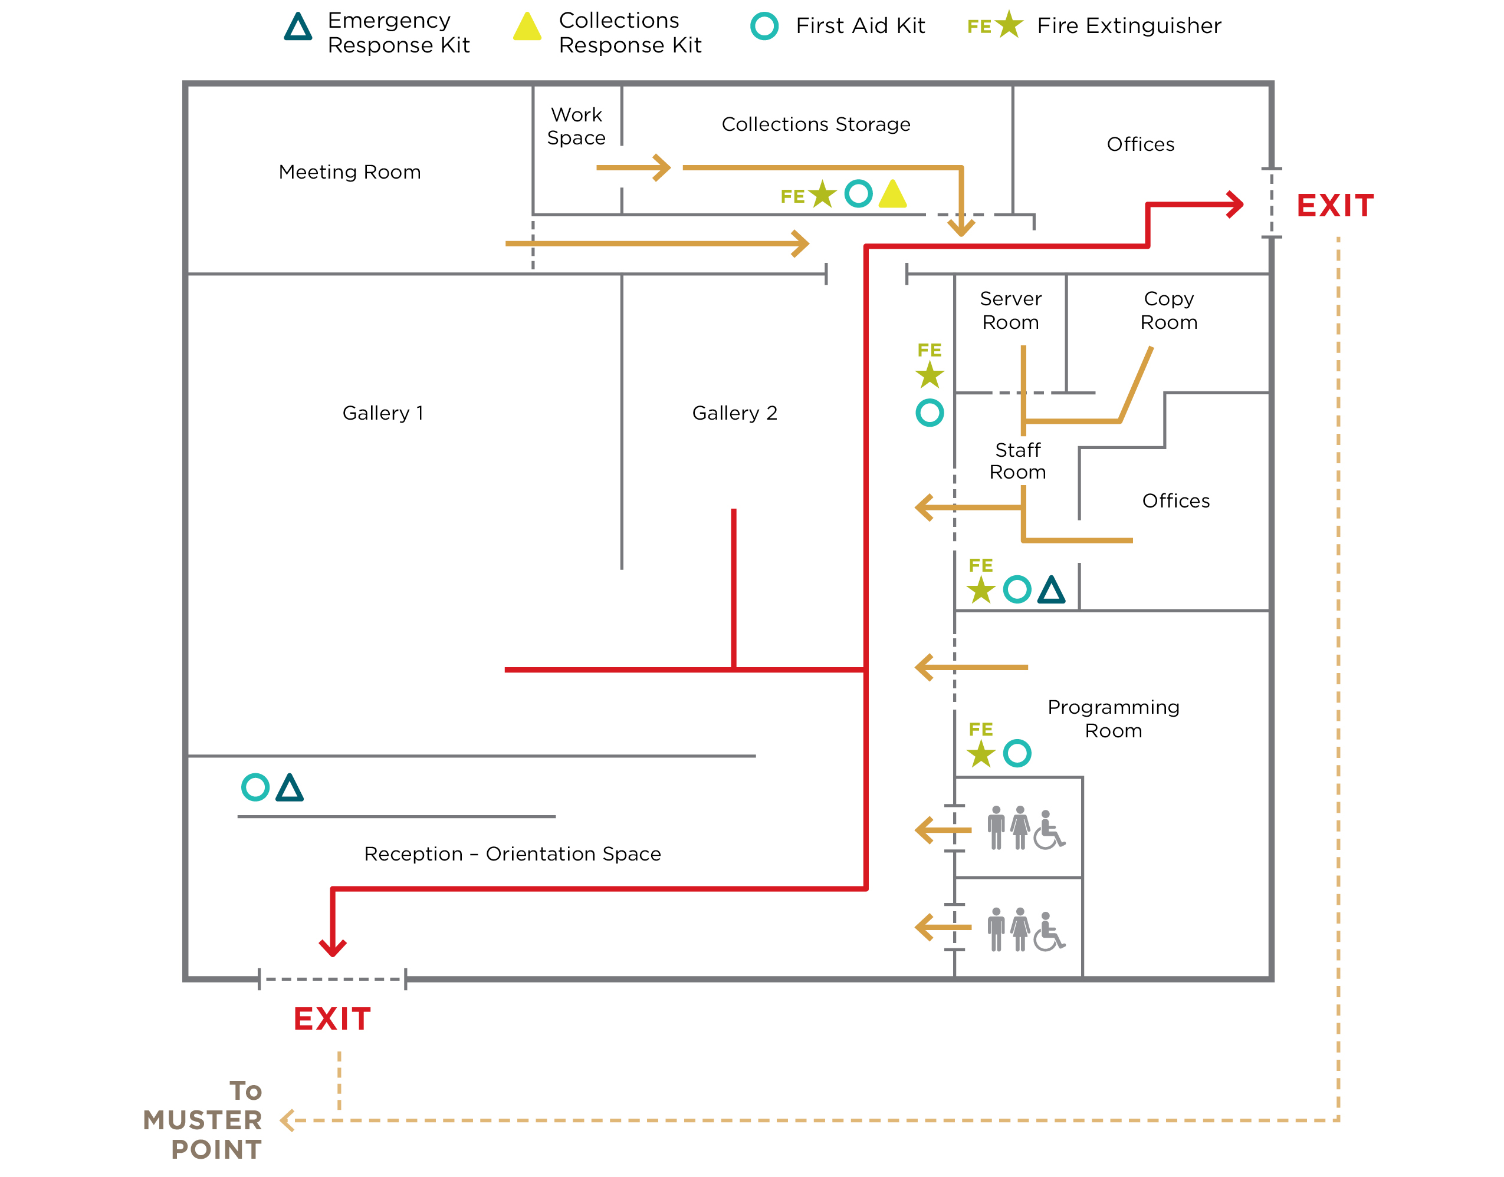
MUSTER POINT: [Insert assembly location away from building.]
In the case of an imminent or occurring emergency requiring evacuation, contact emergency service authorities and see the FIRE AND EVACUATION PROCEDURE immediately.
CALL 9-1-1
TEAR-OUT 3.1 Emergency Preparedness Framework
EVACUATION QUICK GUIDE

EVACUATION—ALL STAFF AND VISITORS
TEAR-OUT 3.1 Emergency Preparedness Framework
EVACUATION QUICK GUIDE

Upon hearing alarm or evacuation order:

REMAIN calm.
FOLLOW INSTRUCTIONS provided on the public address (PA) system.
ADVISE people nearby to evacuate by the nearest exit.
SECURE sensitive material and turn off any hazardous operations if threat is not imminent.
CLOSE doors and windows as you leave if threat is not imminent.
EVACUATE the area / building immediately. Keep moving.
ASSIST anyone requiring help.
DO NOT use elevators.
MEET at the Muster Point well away from the building.
WAIT for further instructions.

EVACUATION—FIRE WARDENS
Upon hearing alarm or evacuation order:

REMAIN calm.
PROVIDE INSTRUCTIONS on the PA system.
ADVISE people nearby to evacuate by nearest exit.
SECURE sensitive material and turn off any hazardous operations if threat is not imminent.
SWEEP through designated spaces to ensure all people have evacuated.
CLOSE doors and windows as you leave if threat
is not imminent.
ASSIST anyone requiring help.
EVACUATE the area / building. Keep moving.
DO NOT use elevators.
MEET at the Muster Point well away from the building.
ACCOUNT for all persons.
COMMUNICATE with Emergency Responders and
relay information to personnel and visitors.

RESPONSIBLE STAFF—FIRE WARDENS
The following staff will assume responsibility for evacuation of the building as designated:

STAFF MEMBER | DUTIES
Name, Fire Warden  [Mobile Phone Number / Direct Line] | Use the PA system to inform all staff, volunteers, and visitors  to exit the building immediately.  Leave building immediately, removing all persons from [area].  Call 9-1-1 from a safe location.  Upon the arrival of the firefighters, provide them with floor plans.  Contact the ERT Lead.
Name, Fire Warden Alternate  [Mobile Phone Number / Direct Line] | Leave building immediately, removing all persons from [list].  Assume responsibilities of Fire Warden if they are unavailable.
Name, Position  [Mobile Phone Number / Direct Line] | Leave building immediately, removing all persons from [list].
Name, Position  [Mobile Phone Number / Direct Line] | Leave building immediately, removing all persons from [list].
Evacuation Quick Guide has been developed with information from Government of Canada, Department of Canadian Heritage, Canadian Conservation Institute,
“Emergency Response Plan—Template” (Ottawa: Canadian Conservation Institute, 2014).

